Episcopal Diocese of Central Florida  1017 E. Robinson Street  Orlando, FL 32801  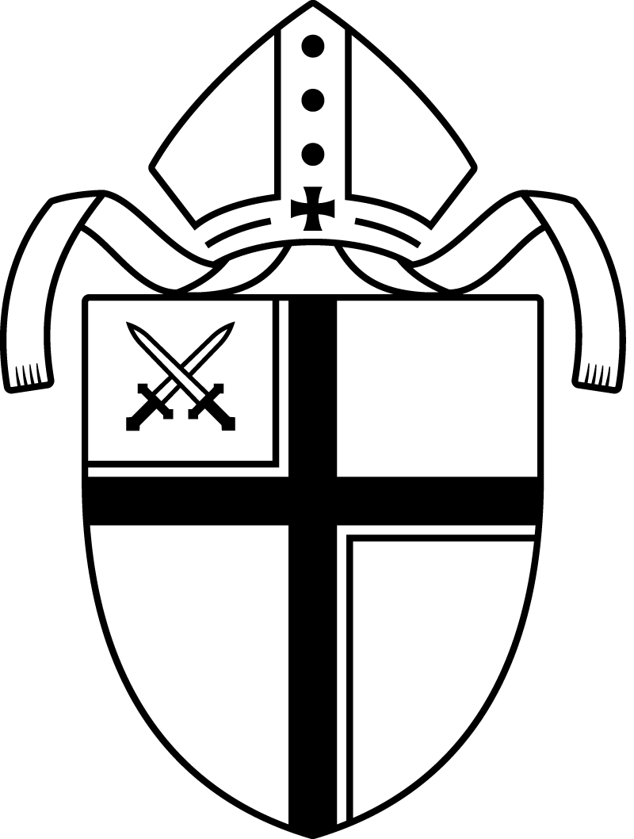 |  |  | Anti-Racism Training  Episcopal Diocese of Central Florida  - 2023

The Anti-Racism Training and Action Program sponsored through the Episcopal Church is a process of and for dismantling racism in the Church and other institutions in society. The Bishop of this Diocese is in full agreement with the sector of the wider Church which has placed racism prevention at the forefront of its obligation to serve God and God's people. The goal set forth here in this booklet is to inform clergy and all people in leadership roles within the Diocese of their obligation to help dismantle the structures of racism and sensitize those who embrace such structures to see the face of God in the people of God. |  |  | From The Book of Common Prayer  For the Human Family  O God, you made us in your own image and redeemed us, through Jesus your Son: Look with compassion on the whole human family; take away the arrogance and hatred which infect our hearts; break down the walls that separate us; unite us in bonds of love; and work through our struggle and confusion to accomplish your purposes on earth; that, in your good time, all nations and races may serve you in harmony around your heavenly throne; through Jesus Christ our Lord. Amen. [Page 815]  For the Diversity of Races and Cultures  O God, who created all peoples in your image, we thank you for the wonderful diversity of races and cultures in this world. Enrich our lives by ever-widening circles of fellowship, and show us your presence in those who differ most from us, until our knowledge of your love is made perfect in our love for all your children; through Jesus Christ our Lord. Amen. [Page 840]  A Prayer for Mission  O God, you have made of one blood all the peoples of the earth, and sent your blessed Son to preach peace to those who are far off and to those who are near; Grant that people everywhere may seek after you and find you; bring the nations into your fold; pour out your Spirit upon all flesh; and hasten the coming of your kingdom; through Jesus Christ our Lord. Amen. [Page 100]
 |  |  | 5

Resources  Dillard, Angela D. Guess Who's Coming to Dinner Now?: Multicultural Conservatism in America. New York University Press, 2001.  Davis, Angela Y. Women Race & Class. New York: Vintage Books, 1983.  Gates, Henry Louis, Jr., and Cornel West. The Future of the Race, New York: A.A. Knopf, 1996.  Haney-Lopez, Ian F. White by Law: The Legal Construction of Race. New York: New York University Press, 1998.  Haines, Byron &  Cooley, Frank L., eds. Christians and Muslims Together: An Exploration by Presbyterians. Philadelphia: Geneva Press, 1997  Hopkins, Dwight N., ed. Black Faith and Public Talk: Critical Essay on James H. Cone's Black Theology and Black Power. Maryknoll, NY: Orbis, 1999.  Anti-Racism Training through the online classes from the Institute for Christian Studies, Diocese of Central Florida. Contact the Dean, the Venerable Kristi Alday at kalday@cfdiocese.org for further information. |  | From the 73rd General Convention  of the Episcopal Church, Denver, Colorado  July 4-15, 2000  Resolution # 8-049 Require Anti-Racism Training  Resolved, That beginning on September l, 2000 the lay and ordained leadership of the Episcopal Church, including all ordained persons, professional staff, and those elected or appointed to positions of leadership on committees, commissions, agencies, and boards be required to take anti-racism training and receive certification of such training; and be it further  Resolved, That the Executive Council select and authorize appropriate programs that will be used at the national level; that each province select and authorize appropriate programs that will be used at the provincial level; and that each diocese select and authorize appropriate programs that will be used at the diocesan and parochial levels, each province and diocese to determine those lay and clergy leaders who are to take the training; and be it further  Resolved, That the Standing Commission on National Concerns continues to develop a list of such appropriate resources; and be it further  Resolved, That each national committee, commission, agency, and board, and each province and diocese maintain a register of those who are trainers and those who have been trained, and forward this information to the Executive Council by January l, 2003, and every two years thereafter, and the Council report on this information to the 74th and 75th General Conventions.  From the 35th Annual Convention  of the Diocese of Central Florida, Winter Park, Florida,  January 23 -24, 2004  Resolution R-1 Anti-Racism  Resolved, That this annual convention of the Diocese of Central Florida does now commit itself to work to become a church committed to ending institutional and other forms of racism in this diocese and that each congregation commit itself to the work of overcoming the sin of racism through dialogue and training offered by the Anti-Racism Commission, and be it further
4 |  |  | 1

Resolved, That the lay and ordained leadership of the Diocese of Central Florida including all ordained persons, professional staff and those elected or appointed to positions of leadership on committees, commissions, agencies, and boards be required to take anti-racism training as provided by the Diocese of Central Florida Anti-Racism Commission; and be it further  Resolved, That all parishes involved in search processes along with their vestries be encouraged to take the Diocese of Central Florida Anti-Racism Dialogue training; and be it further  Resolved, That the Diocese of Central Florida commitment include but not be limited to increasing the recruitment and deployment of minorities as clergy and lay professionals in the church.  + + + + +  In response to Resolution R-1, Bishop Howe invited a group, under the direction of The Reverend Canon Nelson W. Pinder, to meet and to begin crafting a program for anti-racism training that would be of real help to our Diocesan family. The Committee adopted the following Mission Statement in 2005:  “The objective of the Committee on Anti-Racism is to help church  leaders embrace our differences and increase our understanding  of racism, so that we may effectively do ministry and mission with  all God's people in the Diocese of Central Florida.”  Definitions associated with Racism  Racism - The theory that distinctive human characteristics and abilities  are determined by race.  Institutional Racism - Racism finding expression through an institution (eg. a church) and fomented by habit rather than by intent.  Prejudice - A prejudgment on insufficient grounds; it can be positive or negative.  Bigotry - A more intensive form of prejudice which carries the negative side of prejudgment. |  |  | Stereotyping - Attributing characteristics to a group simplistically and uncritically. Often there is the assumption that those characteristics are rooted in significant biological differences; Racial profiling.  Discrimination - The act or practice of according negative differential treatment to individuals or groups on the basis of group, class, or affiliation, such as race, religion, and gender.  Scapegoating - The act or practice of assigning blame or failure to persons or groups, instead of placing it on the person(s) to whom blame or failure actually belongs  What can I do to dismantle Racism?  All Episcopalians have a role to play. Ask yourself: what I can do to promote multicultural reconciliation? What role can I personally play in my church?  - Acknowledge Racism exists.  - Acknowledge that anyone can be a Racist.  - Renew your faith in God as stated in the Book of Common Prayer. Commit yourself to eradicating racism wherever it exists.  - Organize others to join you in your quest for change and reconciliation in social and religious gatherings. Include different races as well as different cultures in activities of the church.  - Join others in Anti-Racism Training and make a special effort to do what is necessary to end racism where ever it exists.  It is the hope of this diocese that we join hands and set a Christian example for future generations of Episcopalians.  In his Pastoral Letter April 15, 2008, our bishop, The Right Reverend John Wadsworth Howe wrote:  "We are committed to making the Great Commandment and the Great  Commission the twin priorities of the Diocese of Central Florida. We  strive to encourage each other to remain faithful to Jesus, loyal to the  Gospel, obedient to God's Word, filled with the spirit, rejoicing in his love."
2 |  |  | 3

